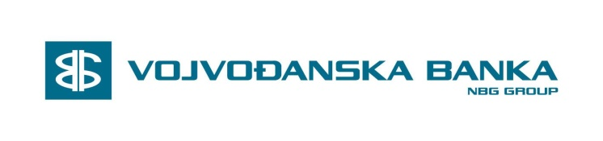

INSTRUKCIJE ZA USMERAVANJE PRILIVA IZ INOSTRANSTVA u EUR
PAYMENT INSTRUCTIONS FOR MONEY TRANSFER IN EUR

56a | Intermediary | DEUTDEFF  Deutsche Bank AG  Frankfurt am Main,DE
57 | Account with Institution | /100 936 5289 0000  VBUBRS22  Vojvodjanska Banka AD,  Novi Sad, RS
59 | Beneficiary Customer | IBAN Number:  RS35355000320034138680  Name&Address:  SRPSKA PRAVOSLAVNA CRKVA  EPARHIJA SABACKA  KARADJORDJEVA 3  SABAC 15000  SERBIA

Vojvodjanska Banka a.d. Novi Sad
Trg Slobode 5-7,
Novi Sad, Srbija
SWIFT CODE: VBUBRS22
Tel: +381-21-4886-762
Fax: +381-21-528-772

