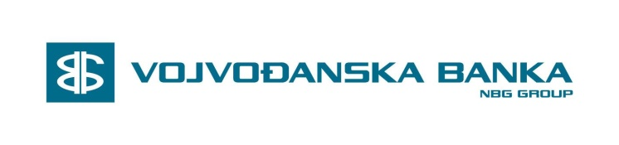

INSTRUKCIJE ZA USMERAVANJE PRILIVA IZ INOSTRANSTVA U USD
PAYMENT INSTRUCTIONS FOR MONEY TRANSFER IN USD

56a | Intermediary | BKTRUS33  Deutsche Bank Trust Company Americas  New York,NY US  ABA ROUTING NUMBER 021001033
57 | Account with Institution | /4415457  VBUBRS22  Vojvodjanska Banka AD, Novi Sad, RS
59 | Beneficiary Customer | IBAN Number:  RS35355000320034139359  Name&Address:  SRPSKA PRAVOSLAVNA CRKVA  EPARHIJA SABACKA  KARADJORDJEVA 3  15000 ŠABAC  SERBIA

Vojvodjanska Banka a.d. Novi Sad
Bulevar Vojvode Misica 41,
Beograd, Srbija
SWIFT CODE: VBUBRS22
Tel: +381-11-225-13-33, 225-13-36
Fax: +381-11-225-13-34
Email: zorica.radanovic@voban.groupnbg.com

